**Curriculum Vitae**

Name : Kyaw Thiha Tun

Applying for : Junior Web Developer

Phone Number : 09-969703874

Email Address : [kyawthihatun56@gmail.com](mailto:kyawthihatun56@gmail.com)

Address : No.403(A5), AungZaya apartment, Middle Kannar, Insein

Career Objective

* Challenges to responsible position which would effectively utilize my prior experience, knowledge and abilities, self-confidence, team spirit, self-motivation and proficiency of technologies as a team player in Software Development.

Personal Data

N.R.C NO. : 12 / AHSANA (N) 242114

Father’s Name : U Than Tun Aung

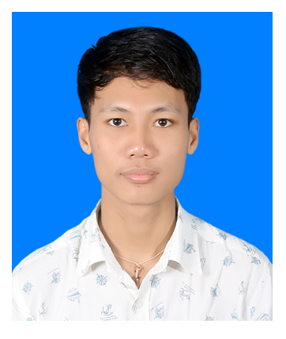

Date of Birth : 13 April 1998

Gender : Male

Marital Status : Single

Nationality : Myanmar

Race : Burmese

Religion : Buddhist

Work Experience

Company : Japan Pleasure Land(JPL)

Position : Sale Leader (Feb 2018 - July 2019)

Educational Background

* Graduated in Matriculation Examination from No.4 B.H.S, Insein (2013 – 2014)
* Studied at Pathein Computer University(UCSP) specified in Computer Science (2015-2017)
* Second Year Class passed from University of Computer Studies Pathein, with distinction(Programming Logic & Web Development and Design Foundations)

Attended Trainings and Classes

Professional Web Developer Course (Fairway Technology)

Self-Studies in Python Programming

Personal Skills

* Good Interpersonal Skill
* Highly team oriented and co-operative
* Motivated to work for long hours with concentration
* Adaptable and flexible person
* Quick learner to new thing

Interest - Foreign Languages, New Technologies, Problem Solving, Collaborate and create new things with team members

Familiar Technologies – HTML 5, CSS, JavaScript, JQuery, MySQL, PHP(Laravel Framework), MVC, CMS(WordPress), Ajax, Bootstrap, Git